Weekly Quiz – Term 1 Week 8
1.  [3]  [2]  [4] | Solve the following equations (show all working and leave answers in exact form):  (a) 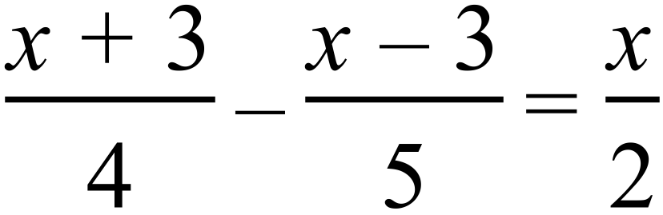  (b) 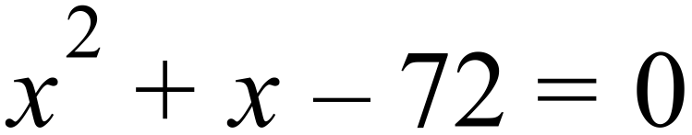  (c) 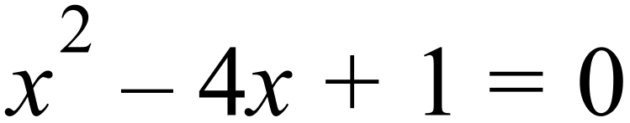
2.  [6] | In the diagram  , 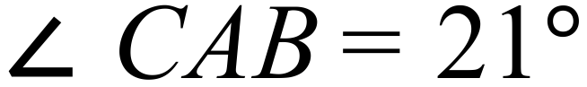 and the exterior angle at B is 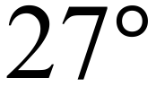 .  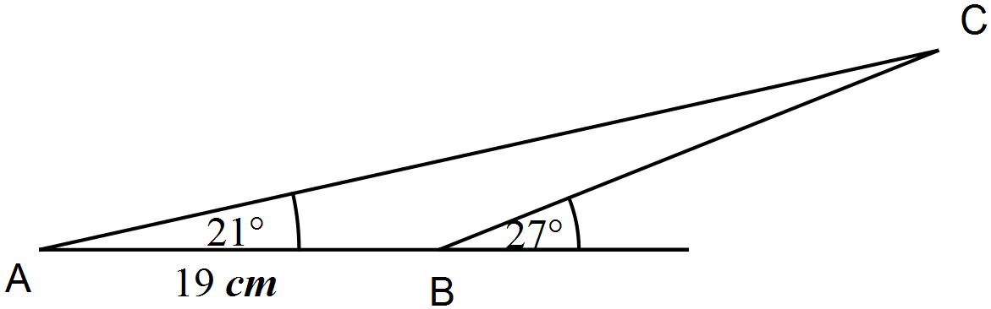  - Calculate the length of BC. (2 marks)  - Calculate the area of triangle ABC. (2 marks)  - Calculate the length of the line from A to the mid-point of BC. (2 marks)
3.  [6] | The cross-section of a wooden hand rail is formed by the intersection of two quadratic functions shown below. The upper curve is modelled by the equation 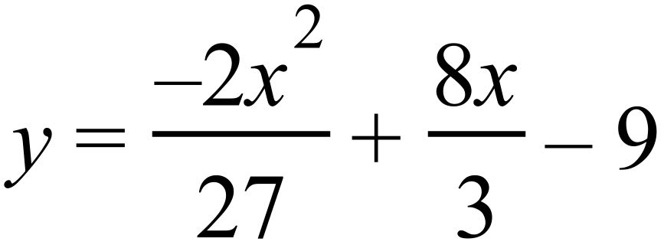 . The equation of the lower curve is a quadratic of the form 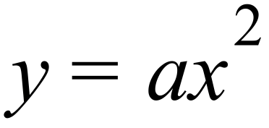 . The two curves meet at 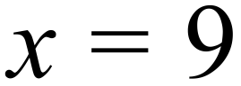 .  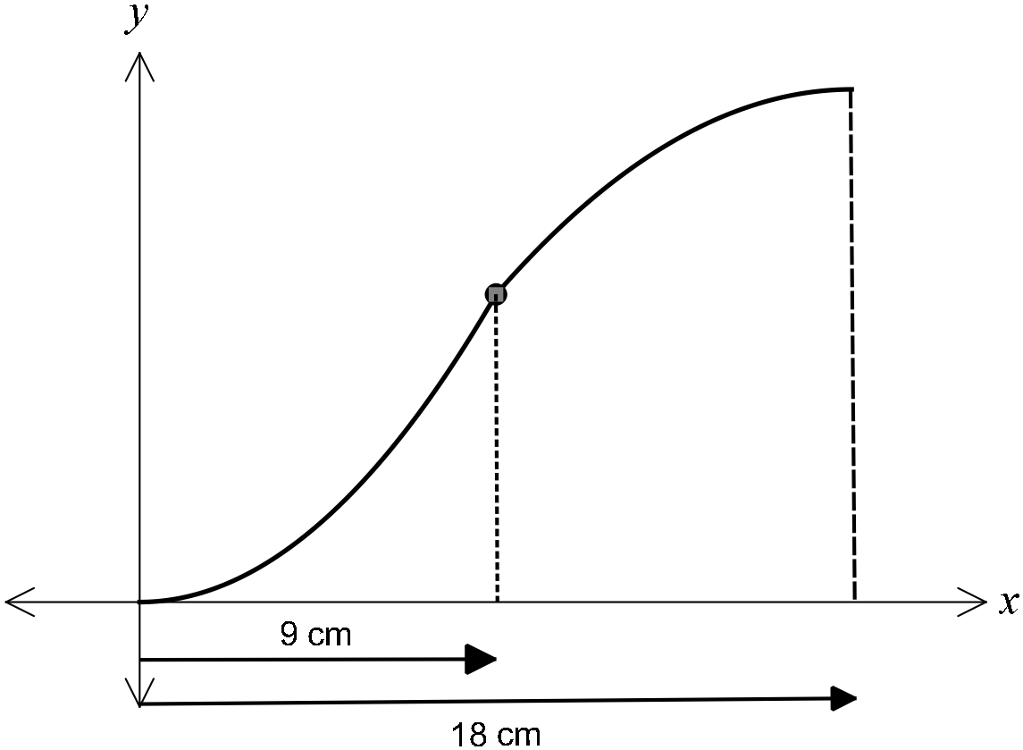  (a) Determine the coordinates of the point where the two curves meet. (2 marks)  (b) Determine and hence state the equation of the lower curve (2 marks)  (c) If the hand rail was moved up 3 cm, determine the new equations of the upper and lower curves. (2 marks)

Solution
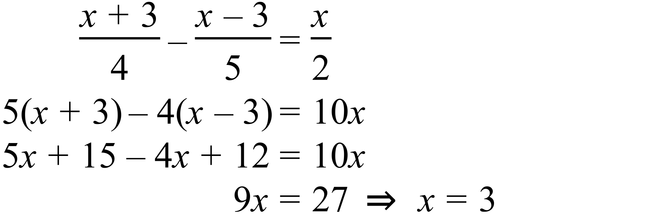

Solution
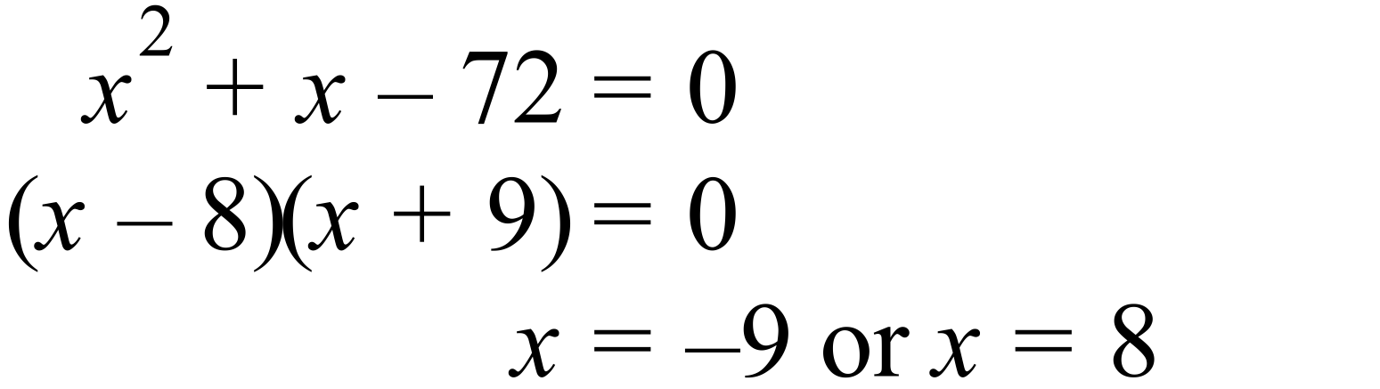

Solution
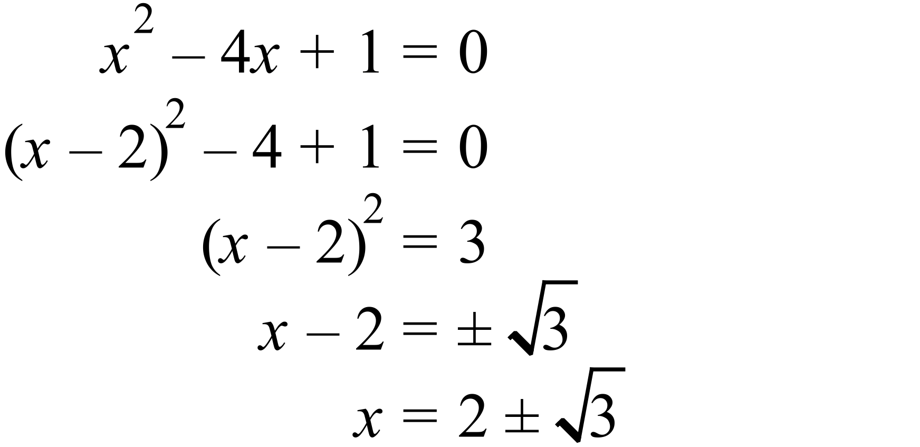
Solution
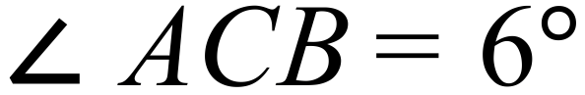

Using the sine rule:

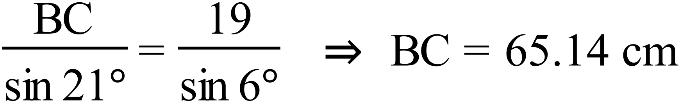

Solution
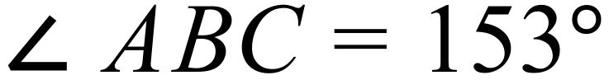
Using the area rule:
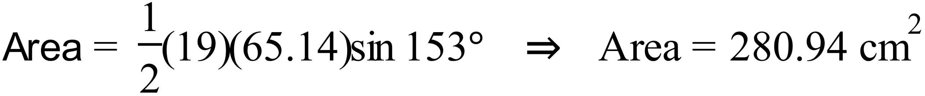

Solution

Let the mid-point of BC be D. BD = 32.57 cm
Using the cosine rule:
Solution
substitute  into upper curve and get
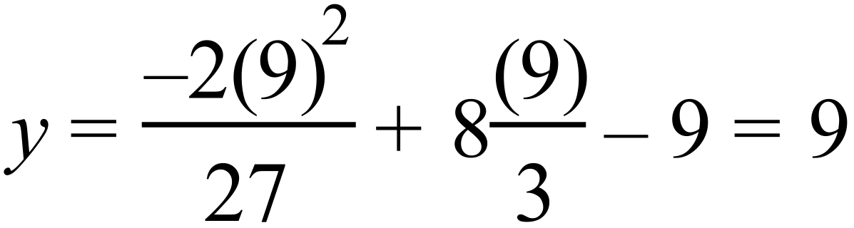
therefore coordinates are (9, 9)

Solution
using the coordinate (9, 9)
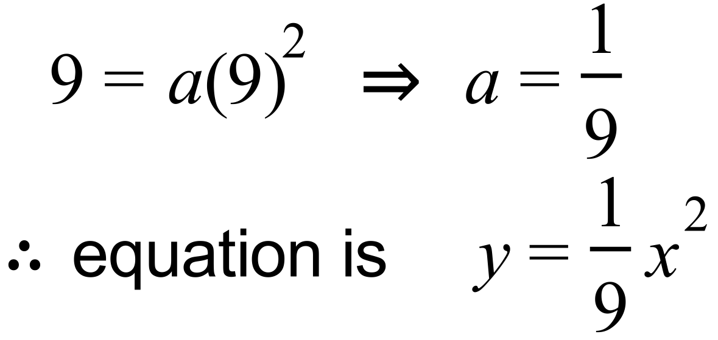

Solution
new upper curve: 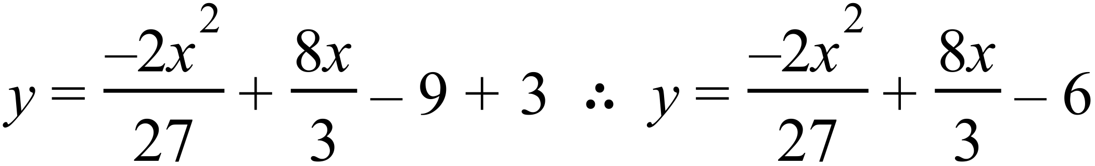
new lower curve: 